CC LAB #2
SUBMITTED BY: AROOBA REHMAN(BSE-012)
SUBMITTED TO: ENGR.MUHAMMAD SHOAIB
- Install Git on your PC.
  - Download Git for Windows, Mac, or Linux
  - Take a screenshot of your installation and save it as git_installation.png in your Lab2 repo.

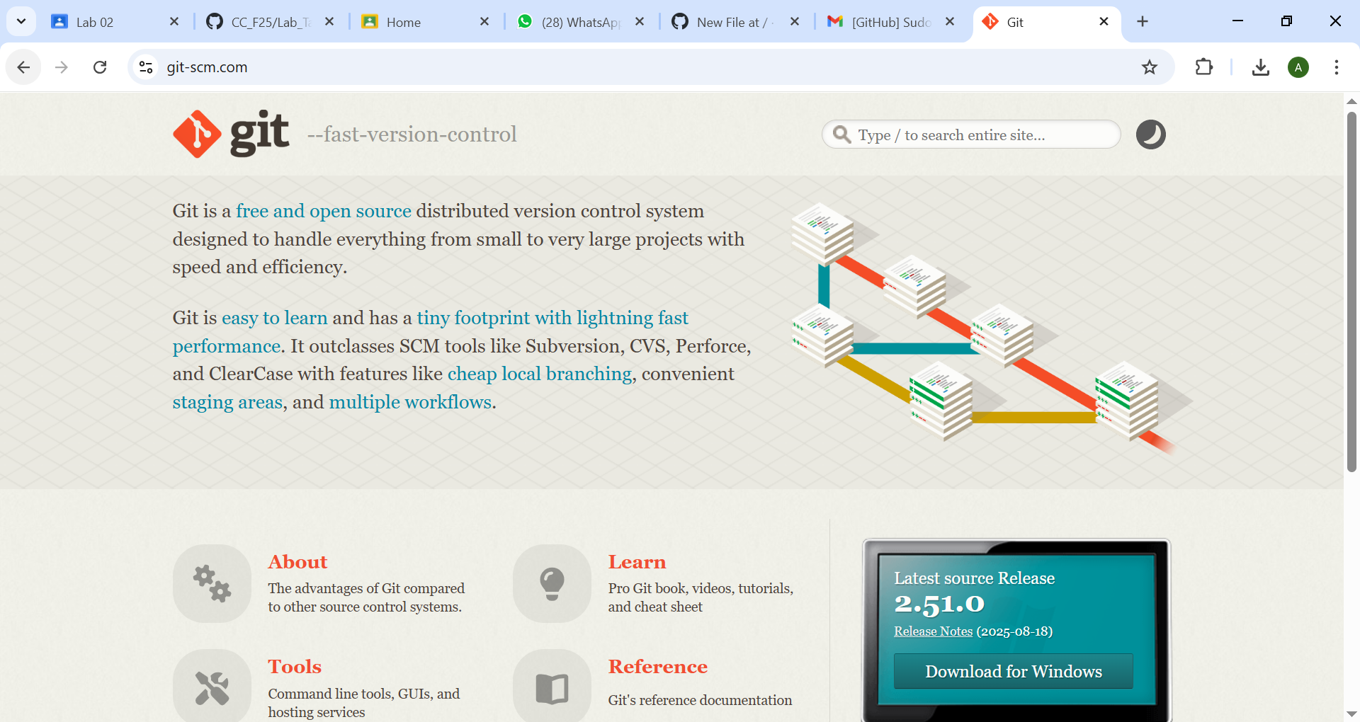
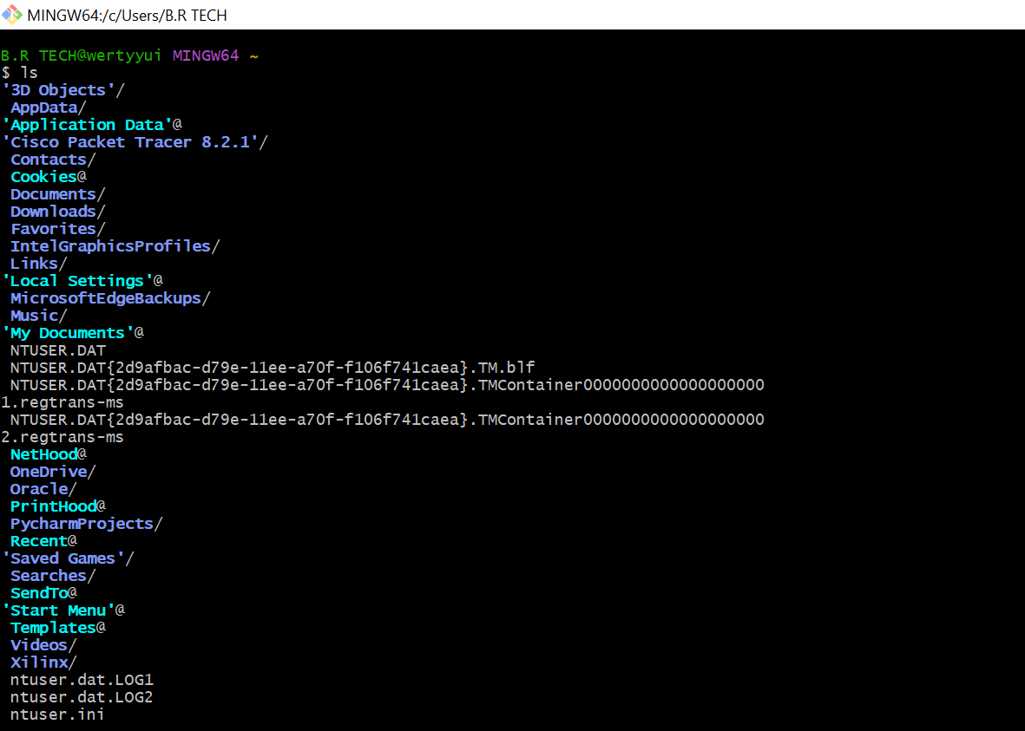

Task 1: Create Private GitHub Repository
- Create a new private repository named Lab2 on GitHub.
- Take a screenshot of your repo settings showing it's private. Save as repo_private.png in your Lab2 repo.

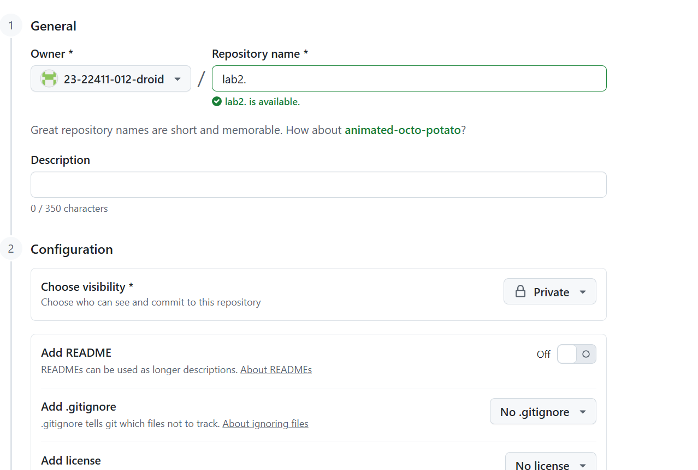

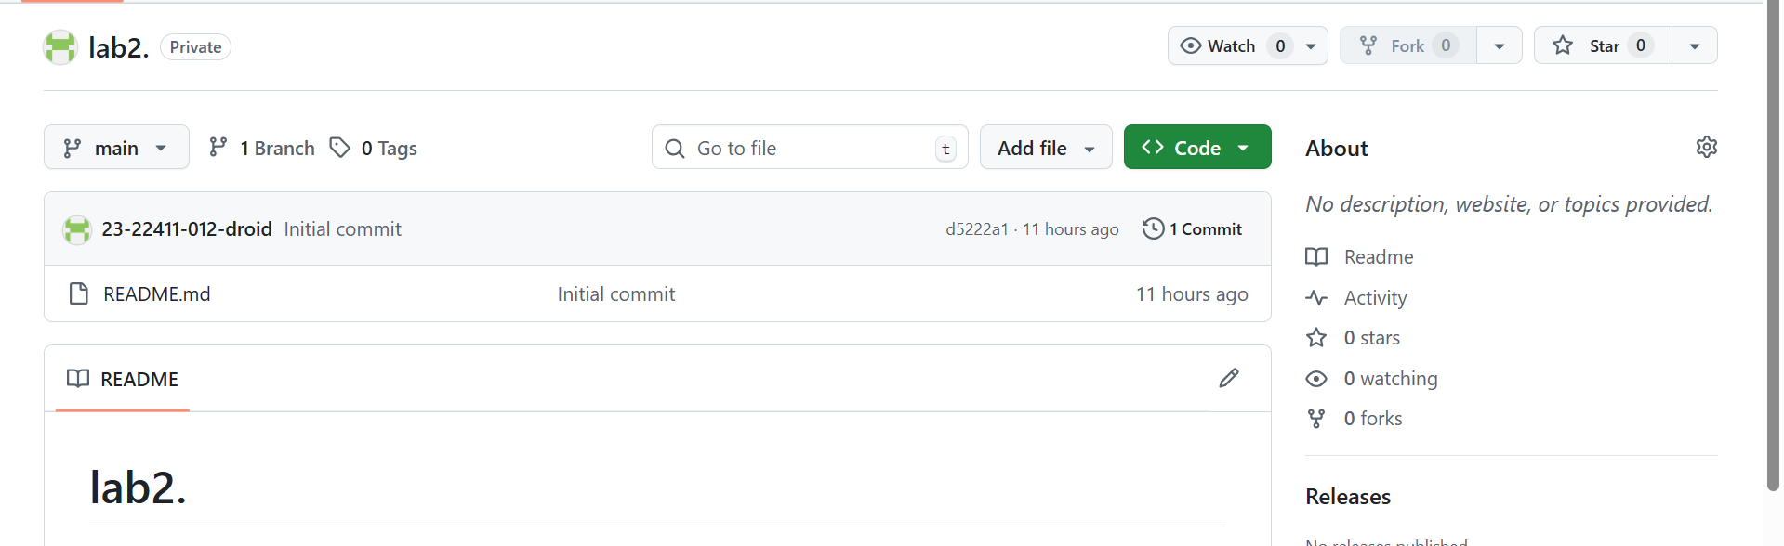

Task 2: Connect Repository via SSH
- Generate a new SSH key using PowerShell:
ssh-keygen -t ed25519 -C "your_email@example.com"
  - Save a screenshot of your terminal after key generation as ssh_keygen.png.
- Add your SSH public key to GitHub (Settings > SSH and GPG keys).
  - Take a screenshot of the added key as github_sshkey.png.
- Clone your Lab2 repo using SSH.
git clone git@github.com:<yourusername>/Lab2.git
  - Save a screenshot as ssh_clone.png.

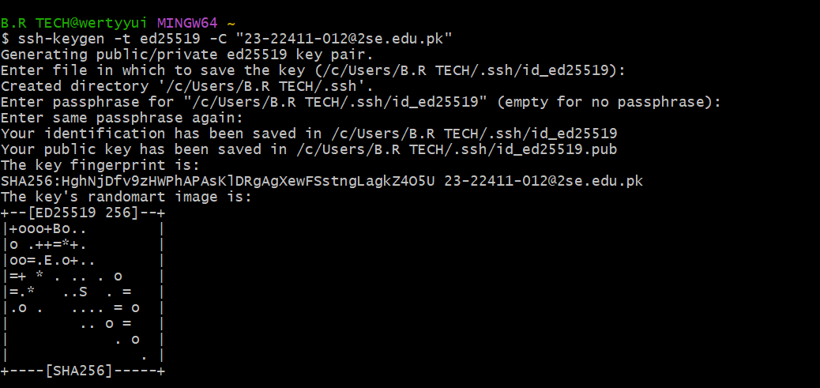

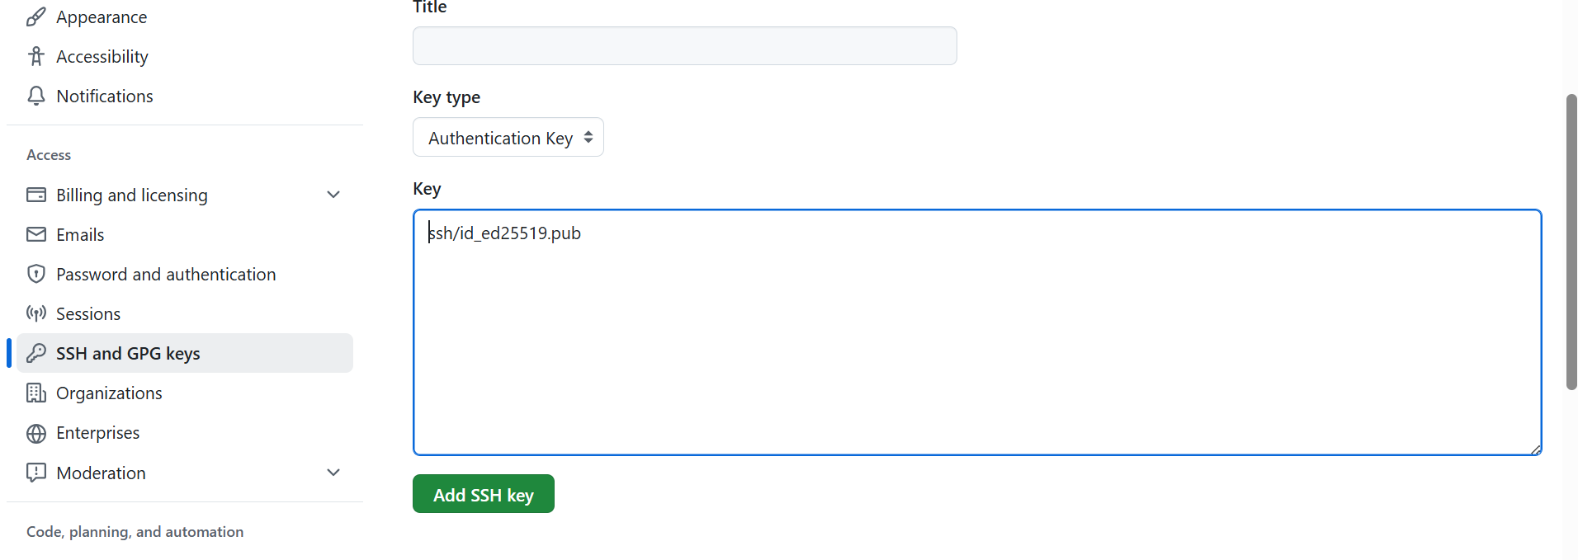
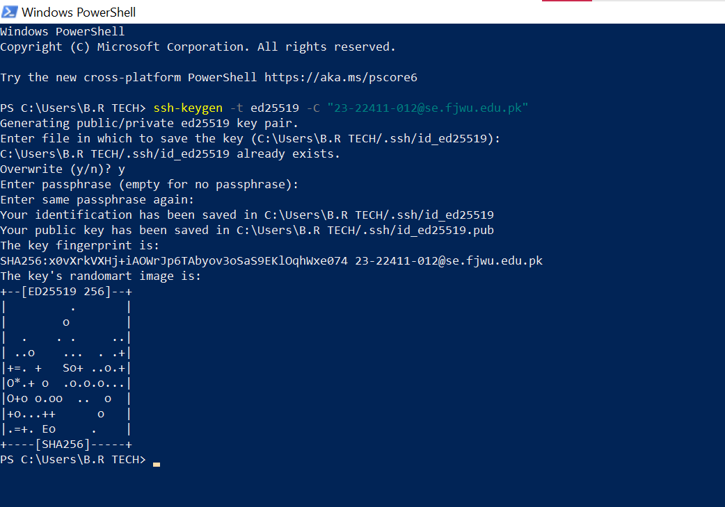
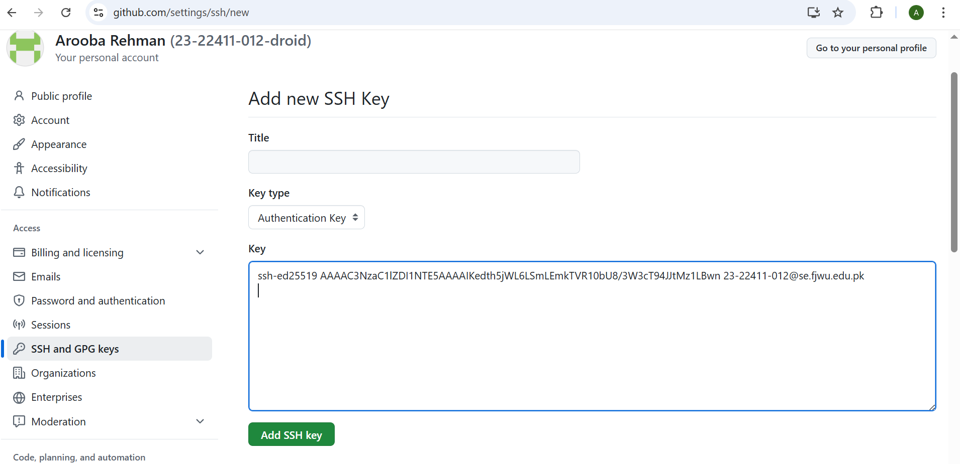
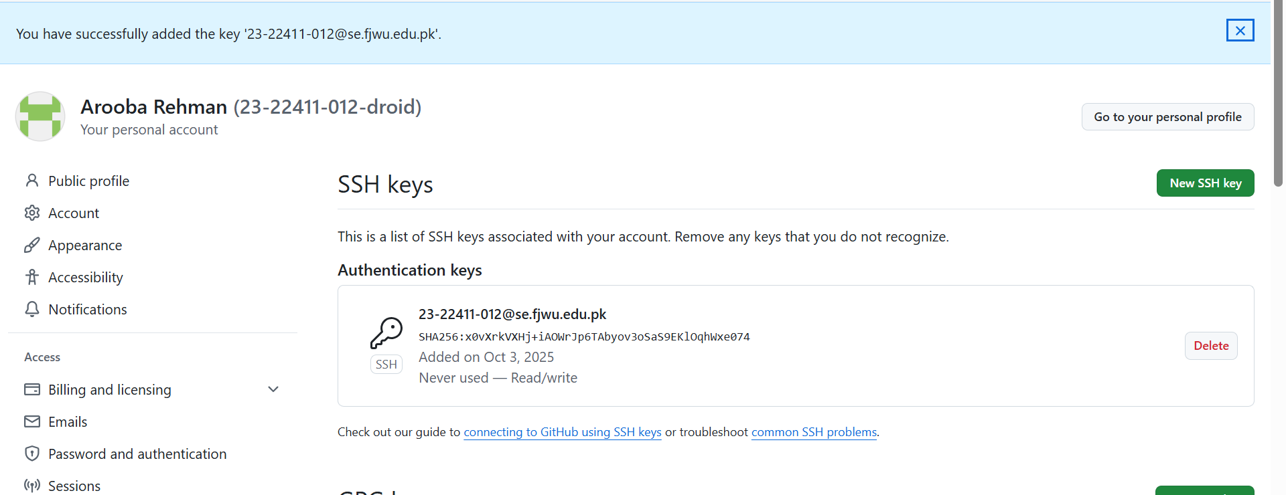

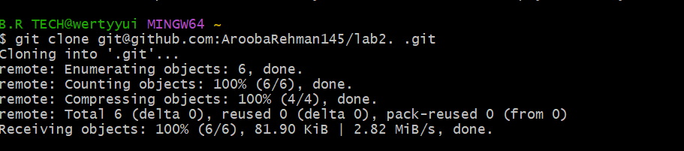

Task 3: Configure Git Username and Email
- Set up your Git identity (this ensures all commits are linked to you):
- git config --global user.name "Your Name"
git config --global user.email "your_email@example.com"
  - Save a screenshot of your terminal as git_identity.png.
- Verify your configuration:
git config --list
  - Screenshot as git_config_list.png.

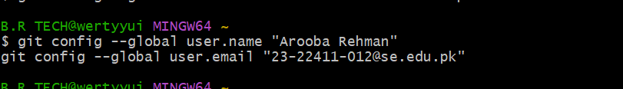
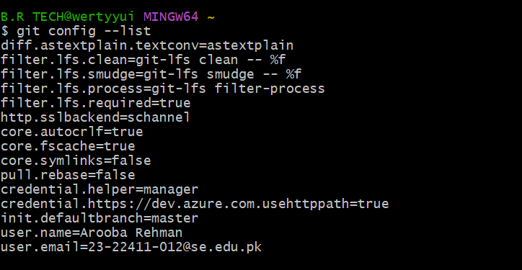

Task 4: Explore the .git Folder
- Navigate into your cloned repository folder.
- Show hidden files and locate the .git directory.
- Explore what’s inside using:
ls -a .git
  - Take a screenshot as git_folder.png.
- Note: This folder contains history, logs, and config for your repository. Do not modify these files manually.

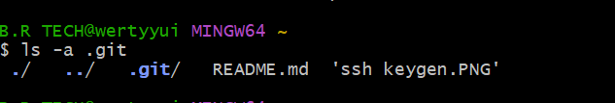

Task 5: Local Repository Management
- Delete the existing .git folder from your cloned repo using Git Bash:
rm -rf .git
  - Take a screenshot as delete_git.png.
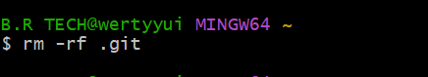
- Re-initialize the local git repository:
git init
  - Save a screenshot as git_init.png.
  - 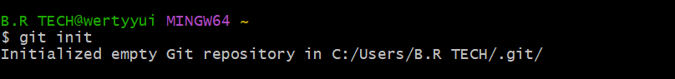
- Add a file named README.md and commit it:
- echo "# Lab2 Git Practice" > README.md
- git add README.md
git commit -m "Initial commit"
  - Save a screenshot as first_commit.png.
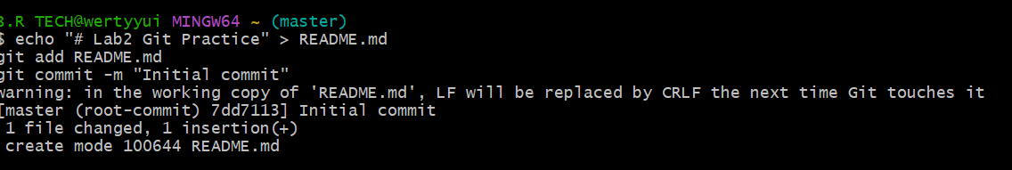

- Connect your local repo to GitHub and push:
- git remote add origin git@github.com:<yourusername>/Lab2.git
git push -u origin master
  - Save a screenshot as first_push.png.

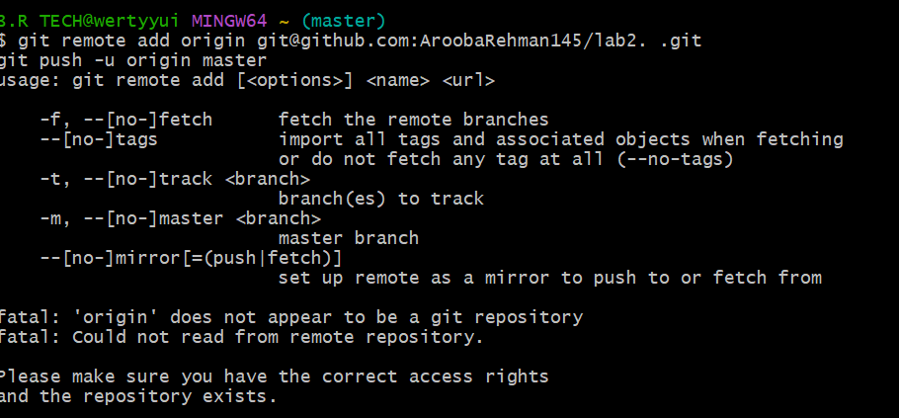

Task 6: File Status & Staging
- Create a new file notes.txt and write a note.
- Check status:
git status
  - Screenshot as status1.png.
  - 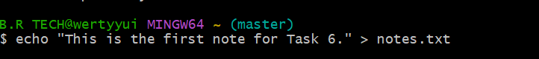
- Stage and commit:
- git add notes.txt
git commit -m "Add notes.txt"
  - Screenshot as commit_notes.png.
  - 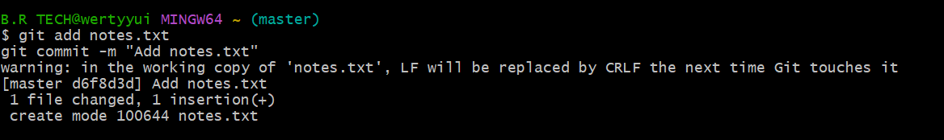
- Edit notes.txt and repeat status/commit steps.

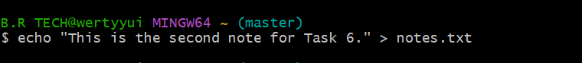

Task 7: Branch Creation Using GitHub GUI
- On GitHub (web interface), create a branch named bugfix/user-auth-error.
- Pull the branch to your local repository to sync.
git pull origin bugfix/user-auth-error
  - Take a screenshot of branch creation in the GUI as bugfix_branch_gui.png.
  - Take a screenshot of your local git branch list after pulling as bugfix_branch_local.png.

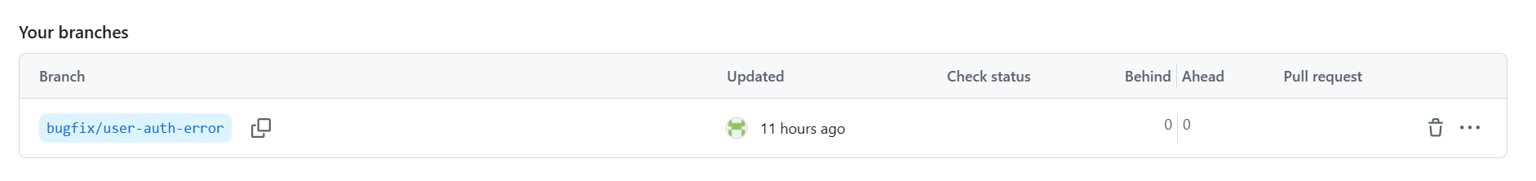

Task 8: Branch Creation and Push Using Git Bash
- Create a branch named feature/db-connection using Git Bash:
git checkout -b feature/db-connection
- Push the branch to the remote repository:
git push origin feature/db-connection
  - Take a screenshot of the branch creation and push as feature_db_branch.png.

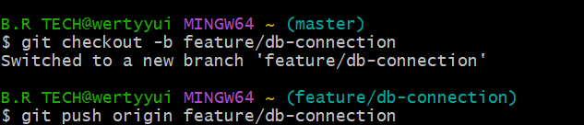

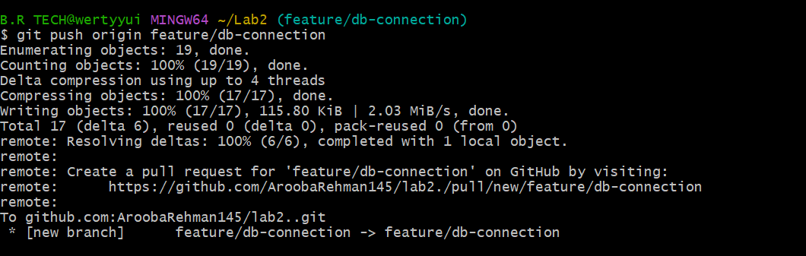

Task 9: Branching & Merging
- Create and switch to a branch feature-1:
git checkout -b feature-1
  - Screenshot as branch_create.png.
  - 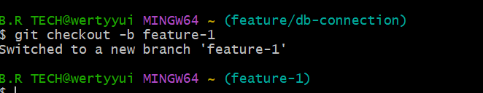

- Modify main.py (add a function) and commit.
- git add main.py
git commit -m "Add new function to main.py"
  - Screenshot as feature_commit.png.
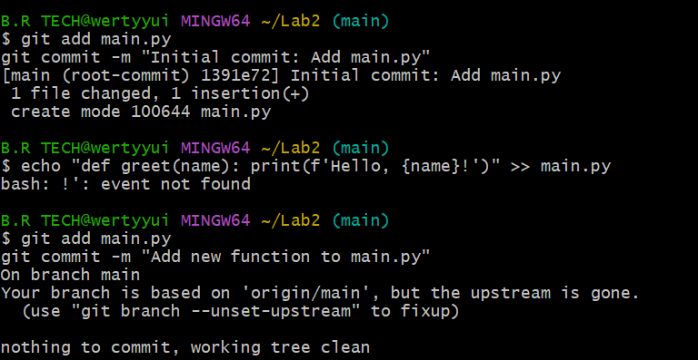
- Switch back to master and merge:
- git checkout master
git merge feature-1
  - Screenshot as merge.png.
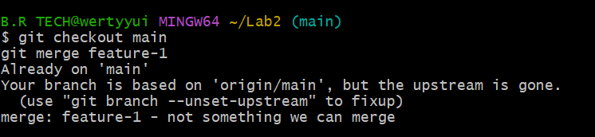
- Push all branches:
- git push origin master
git push origin feature-1
  - Screenshot as push_branches.png.

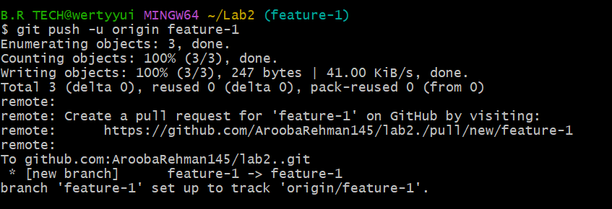

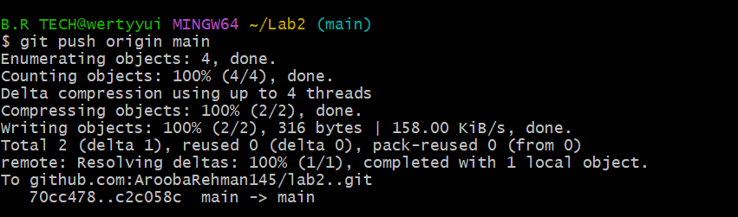

Task 10: Pull Request and Branch Review (GitHub GUI)
- On GitHub, create a Pull Request from the branch feature/db-connection to main.
- Review the Pull Request and merge it using the GitHub GUI.
- After merging, delete the feature/db-connection branch using the GitHub GUI.
  - Take a screenshot of:
    - The Pull Request creation (pr_creation.png)
    - The Pull Request review and merge (pr_merge.png)
    - The branch deletion (branch_delete.png)

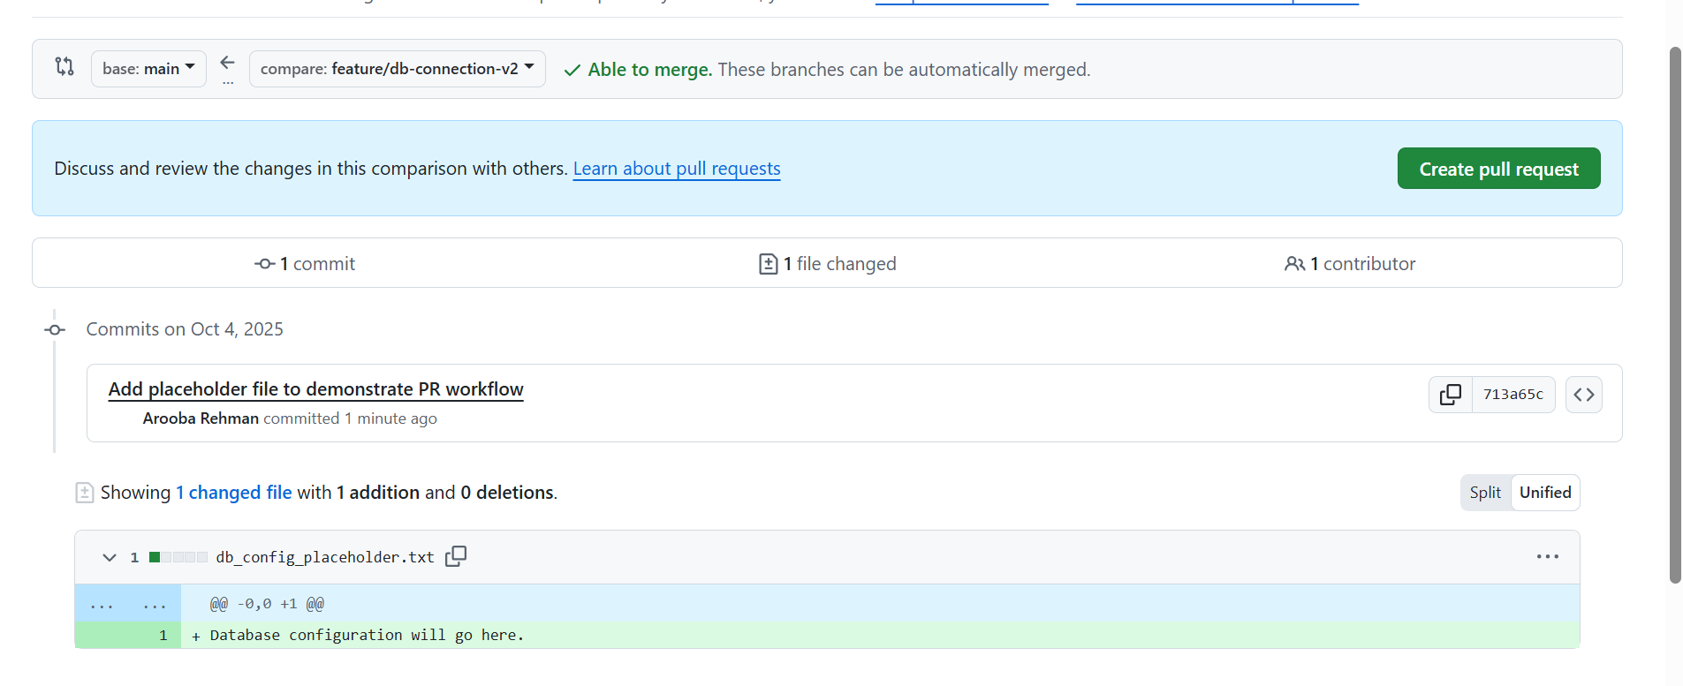
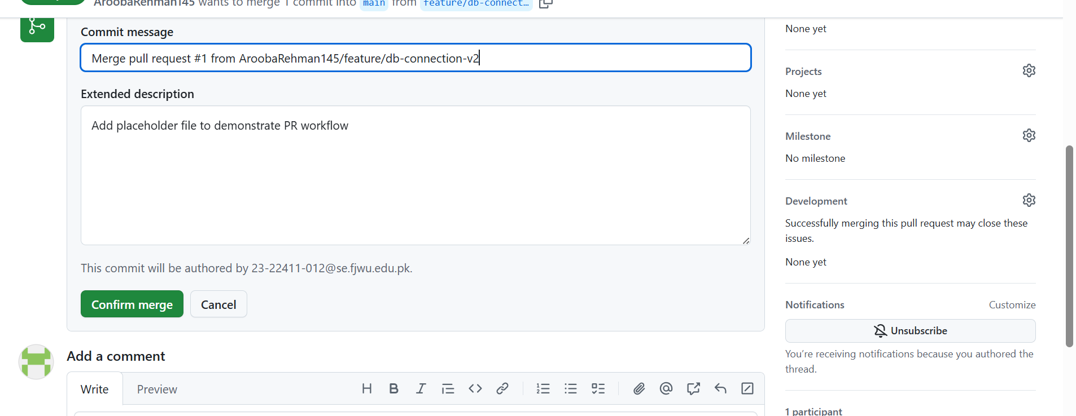

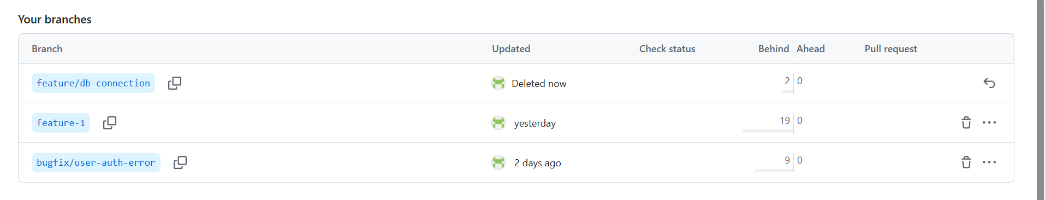

Task 11: Detailed Branch Strategy (Develop/Staging)
- Create the following branches to simulate a professional branching strategy:
  - develop
  - staging
  - feature/*
  - bugfix/*
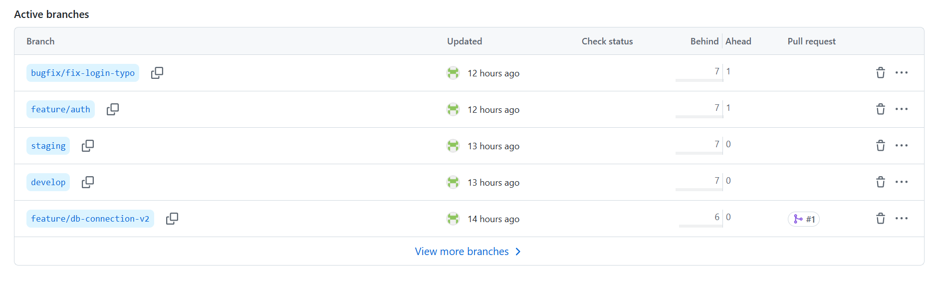
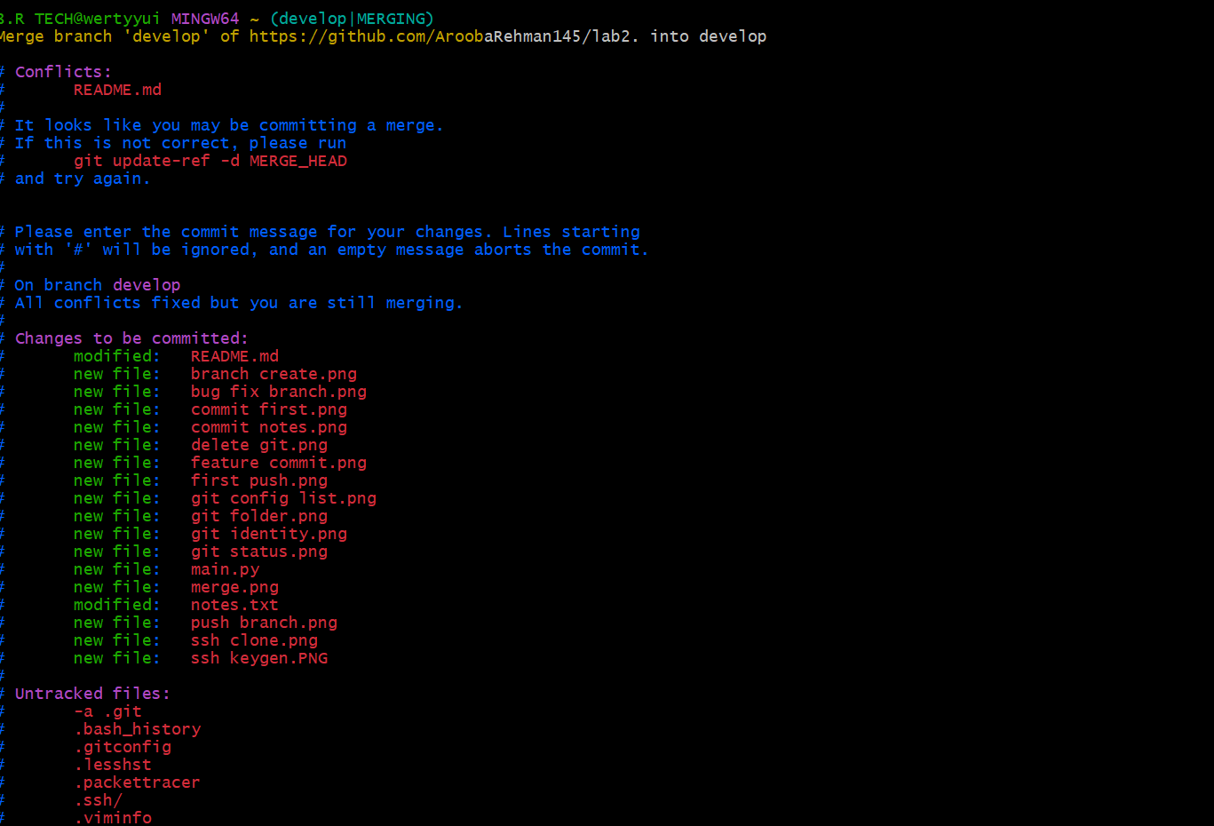
- Example workflow:
  - Developers work on feature/* and bugfix/* branches.
  - Merge into develop after completion.
  - develop is merged into staging for testing.
  - Finally, staging is merged into master (production).
- Document the workflow with screenshots:
  - Branch list (branch_strategy.png)
  - Merges into develop and staging (branch_merges.png)
  - Final merge into master (final_merge.png)

Task 12: Code Review Workflow
- Create a Pull Request (PR) / Merge Request (MR):
  - From a feature branch into main.
  - Add a clear title and description summarizing the changes.
  - Screenshot as pr_create_details.png.
- Assign a reviewer (teammate or second account).
  - Screenshot as pr_assigned_reviewer.png.
- Reviewer Actions (capture screenshots for each):
  - Approve the PR → pr_approved.png
  - Request changes and add comments → pr_request_changes.png
  - Optionally reject/close the PR → pr_rejected.png
- Author Actions:
  - Fix issues in the same branch and push new commits.
  - PR updates automatically.
  - Screenshot updated PR with new commits → pr_updated_with_commits.png.
- Merge the PR:
  - Reviewer approves → merge using GitHub/GitLab UI.
  - Choose merge style (merge commit, squash, or rebase).
  - Screenshot confirmation → pr_merge_confirm.png.
  - Screenshot result → pr_merged.png.
- Branch Handling After Merge:
  - If deleted, screenshot → pr_branch_deleted.png.
  - If kept, add explanation in REVIEW_NOTES.md.

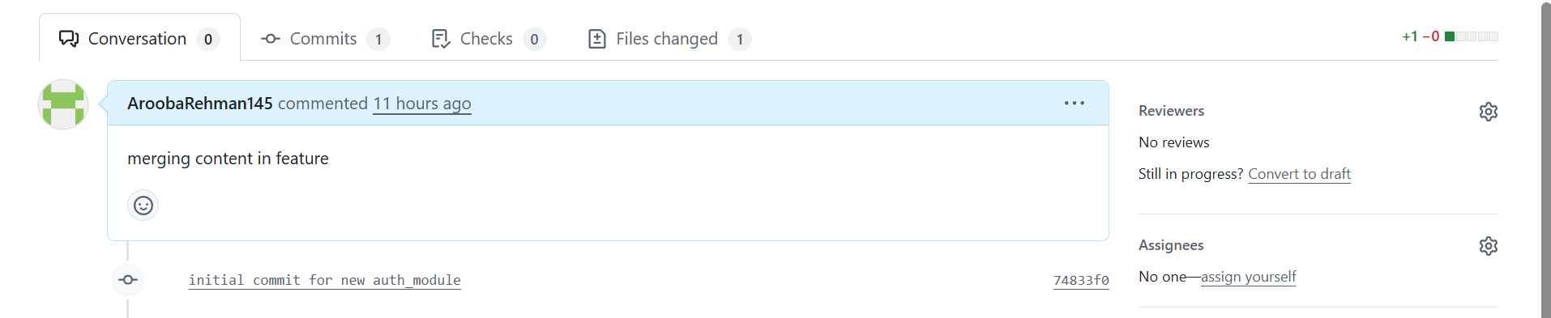
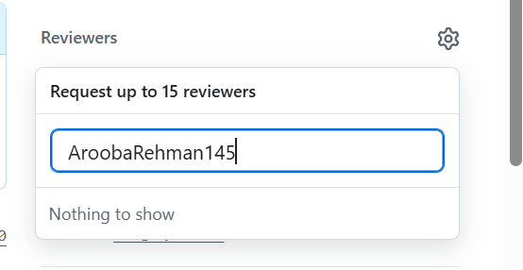
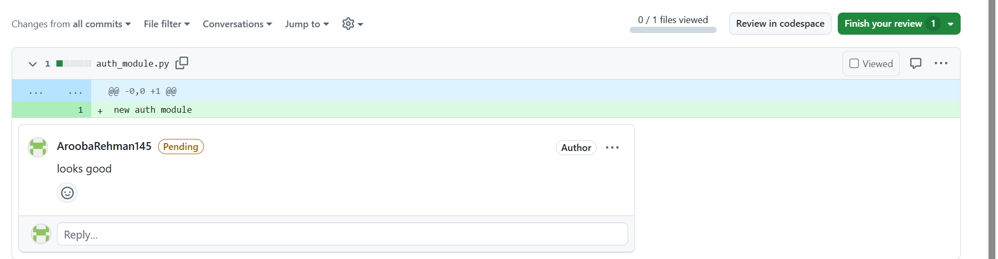
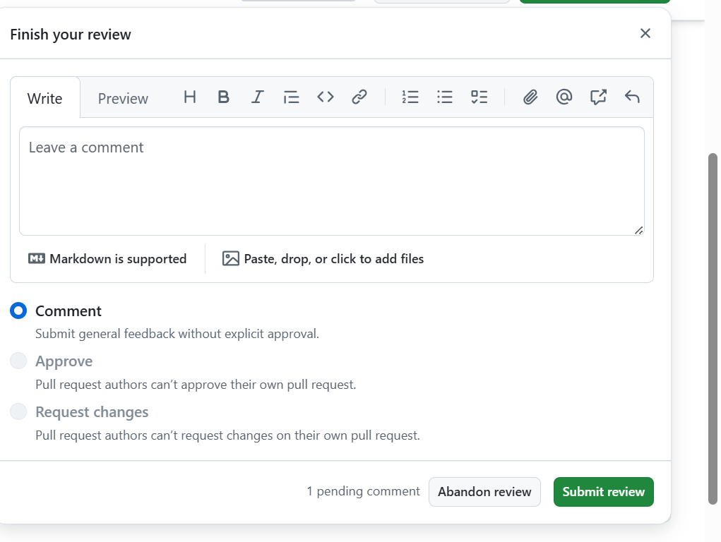

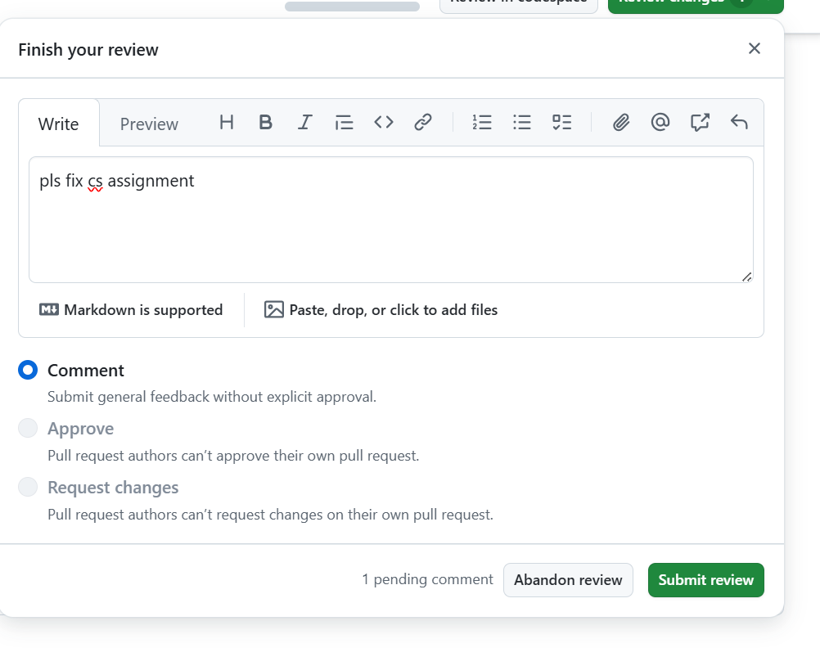
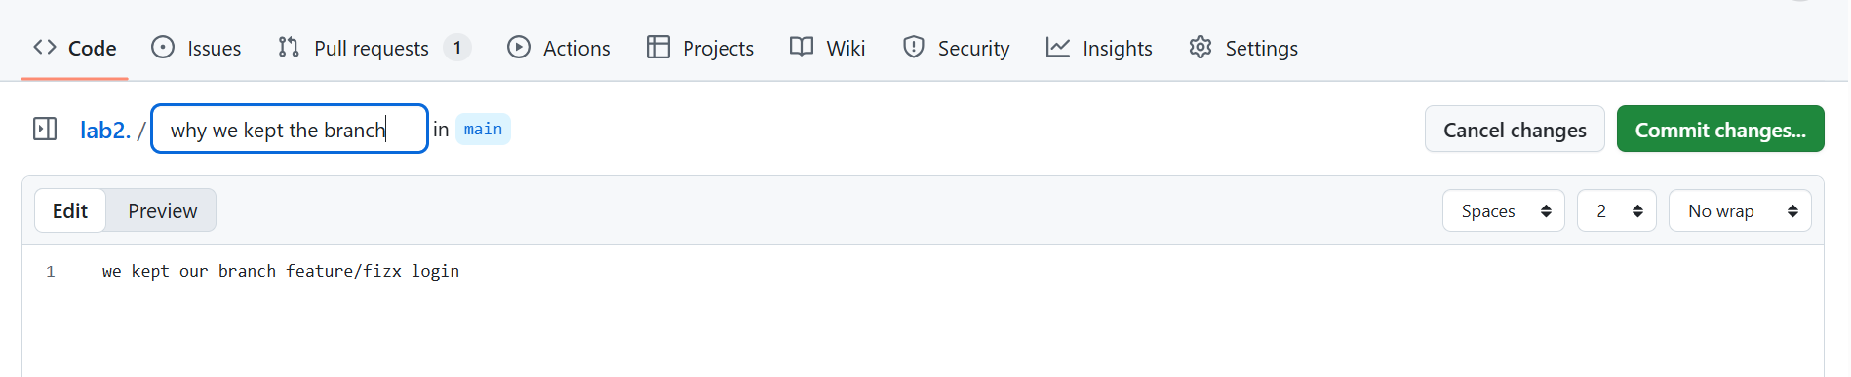

ask 13: Branch Cleanup Best Practices
- Delete Remote Branch After Merge:
  - Use GitHub UI → screenshot remote_branch_deleted.png.
    - Screenshot as remote_branch_delete_cmd.png.
- Update Local Repository:
- git checkout main
- git pull origin main
- git branch -d <branch-name>
git branch

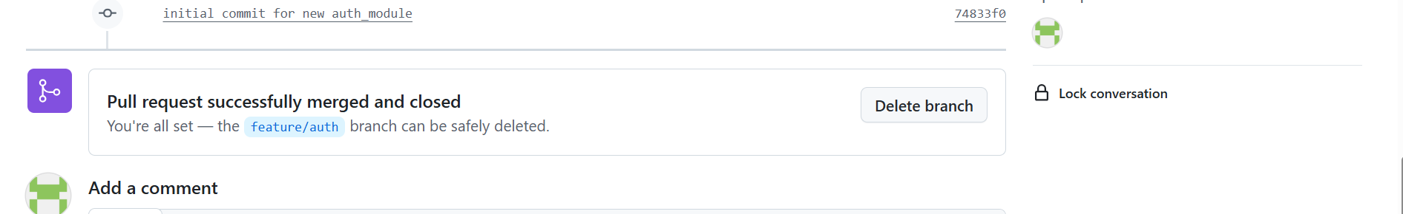
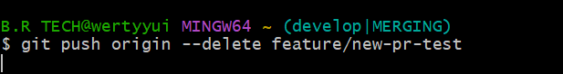

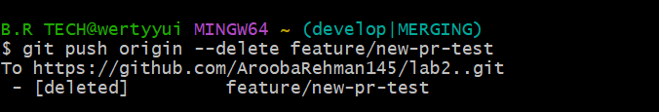
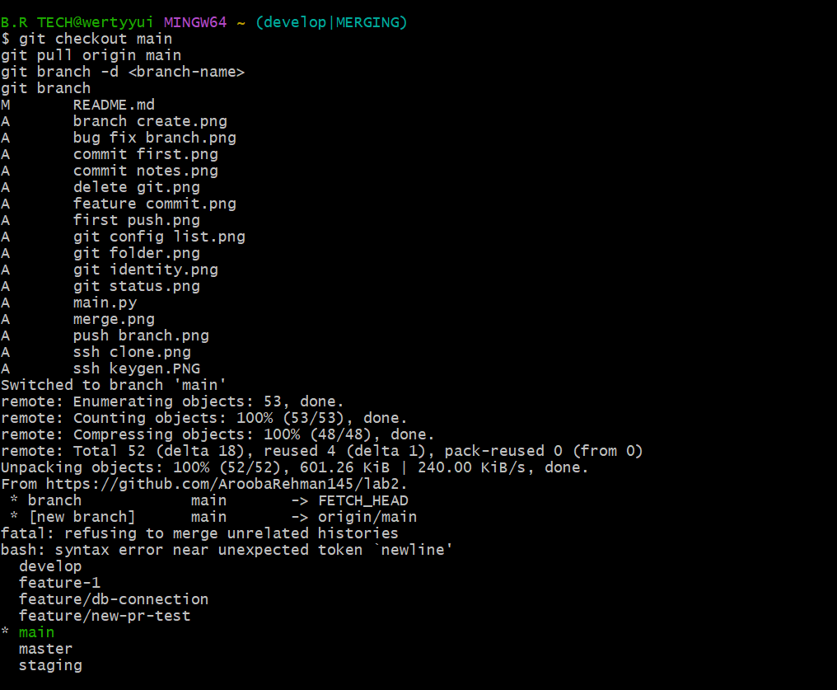

Bonus Task: Simulated Team Collaboration
- Create a branch collab.
- Add a collaborator on your GitHub repo.
- Both users:
  - Pull latest changes.
  - Add their name and fun fact to notes.txt.
  - Commit and push to the collab branch.
  - Screenshot as collab_commit.png.
- Merge collab into master and push.
- git checkout master
- git merge collab
git push origin master
  - Screenshot as collab_merge.png.

